Streamlining Ticket Assignment

For Efficient Support Operations

Team Id: NM2025TMID13167
Team Members: 4
Team Leader: JAYALAKSHMI.M
Team Member 1 : HARINI .R
Team Member 2 : SARASWATHI.H
Team Member 3 : SUJI.T
Problem Statement: In many support operations, ticket assignment
is done manually or through inefficient processes, which often leads to delays, misrouting of requests, uneven workload distribution among agents, and poor customer satisfaction. The lack of an optimized system for assigning tickets results in longer resolutiontimes and decreased efficiency in handling customer issues.Therefore, there is a need to streamline the ticket assignment process to ensure that support requests are routed to the right team or agent quickly and accurately.
Objective:
“Streamlining Ticket Assignment for Efficient Support Operations”
Streamlining → making a process simpler, faster, and smoother.
Ticket Assignment → deciding which support request (ticket) should go to which support agent or team.
Efficient Support Operations → running customer support in a way that saves time, reduces errors, and improves service quality.

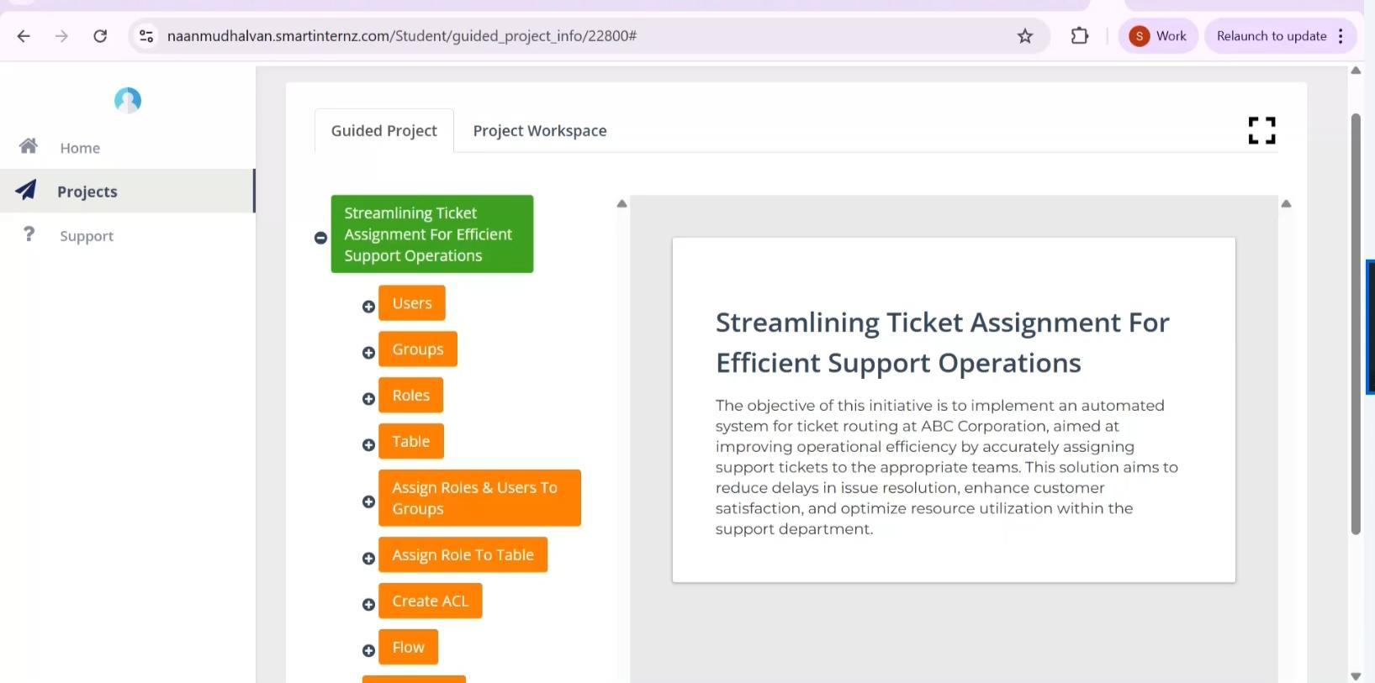

TASK INTENTION
Milestone 1 : Users
Activity 1: Create Users
Open service now
Click on All >> search for users
Select Users under system security
Click on new
Fill the following details to create a new user
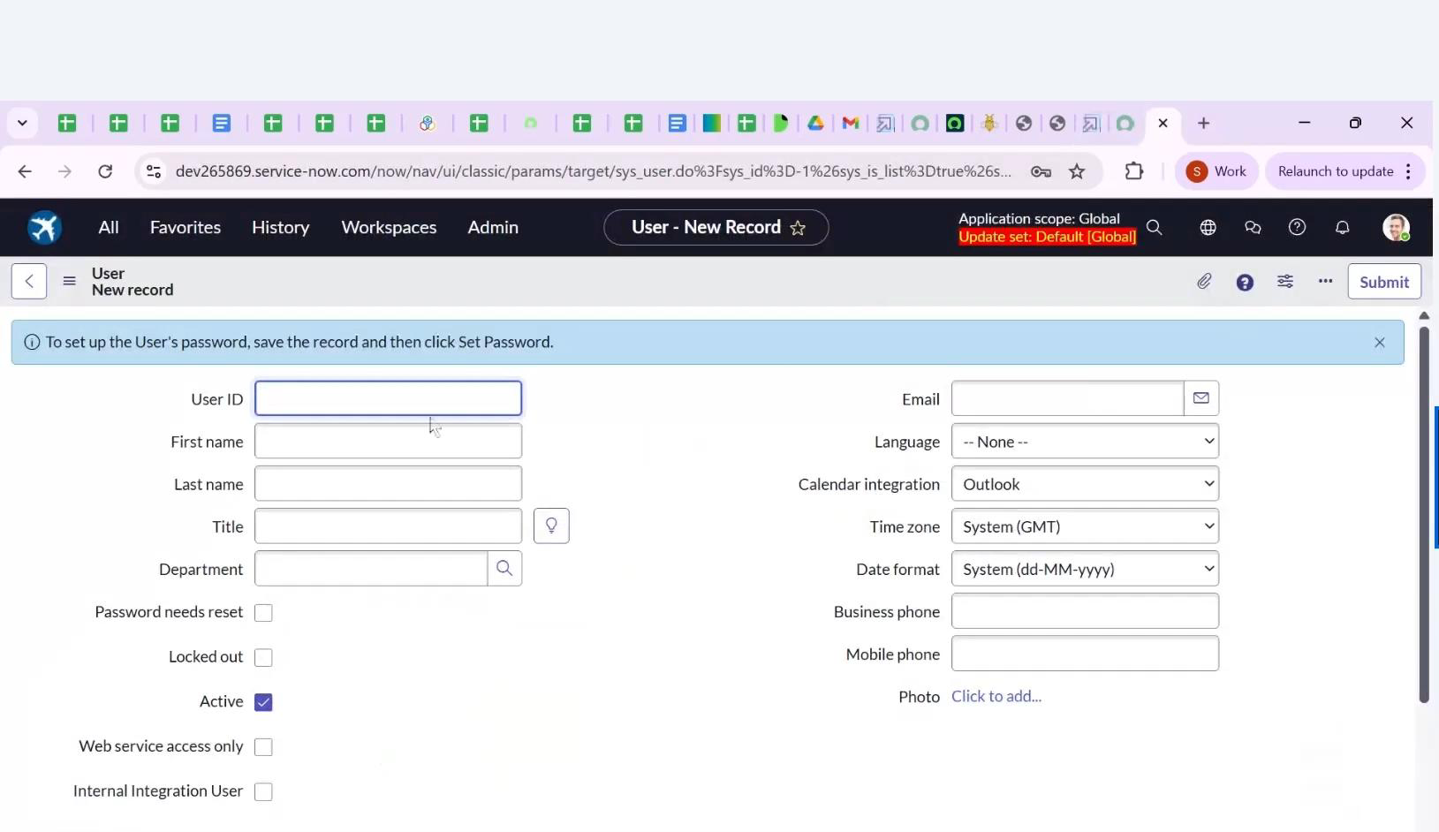
Click on submit
Create one more user:
Create another user with the following details

Activity 1: Create Groups
1. Open service now.
2. Click on All >> search for groups
3. Select groups under system security
4. Click on new
5. Fill the following details to create a new group
6. Click on submit

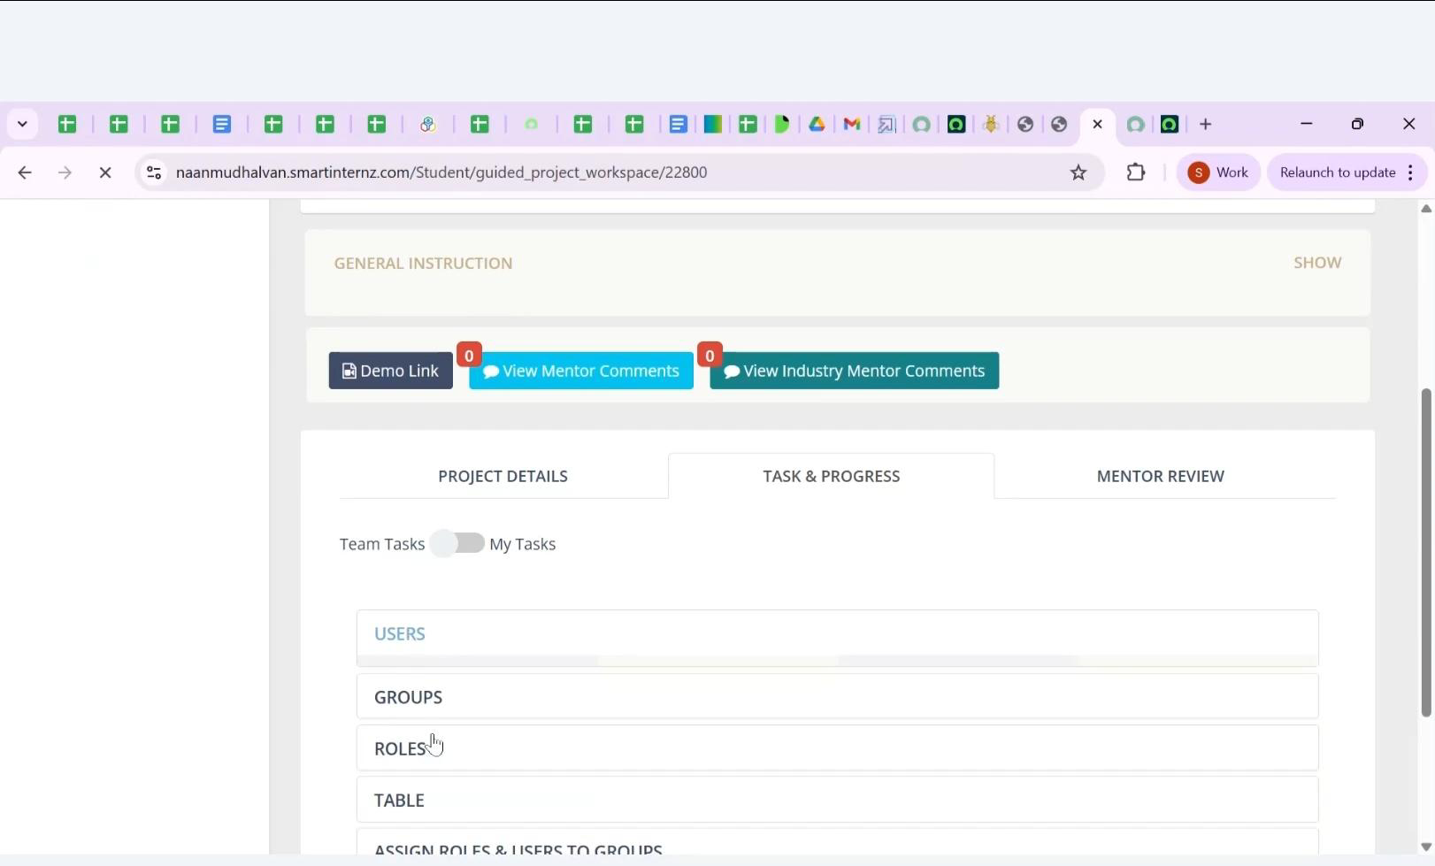

Milestone 3 : Roles
Activity 1: Create roles
1. Open service now.
2. Click on All >> search for roles
3. Select roles under system security
4. Click on new
5. Fill the following details to create a new role
6. Click on submit
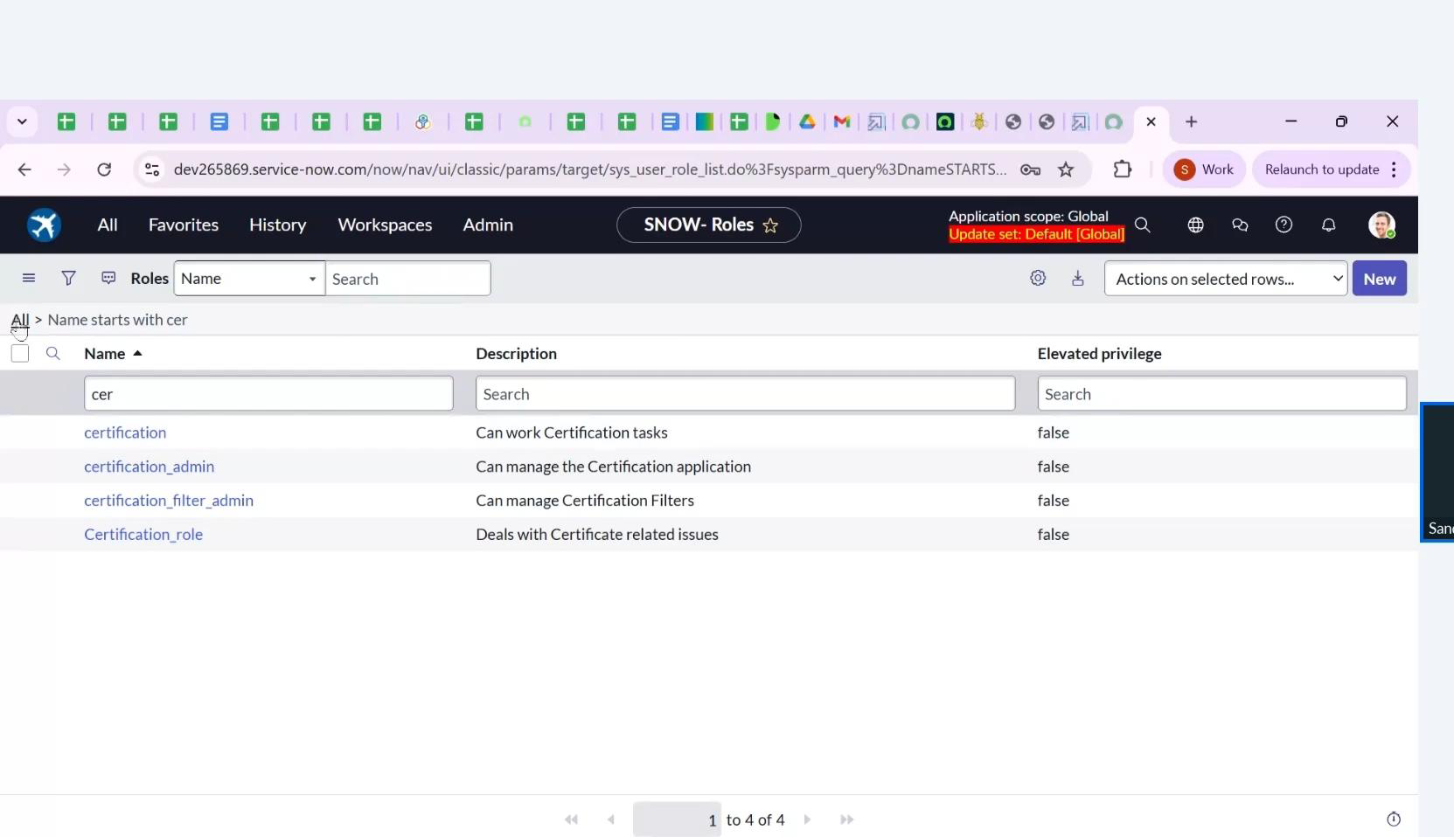
Create one more role:
7.Create another role with the following details
8.Click on submit

Milestone 4 : Table
Activity 1: Create Table
1. Open service now.
2. Click on All >> search for tables
3. Select tables under system definition
4. Click on new
5. Fill the following details to create a new table
Label : project table
Check the boxes Create module & Create mobile module
6. Under new menu name : project table
7. Under table columns give the columns

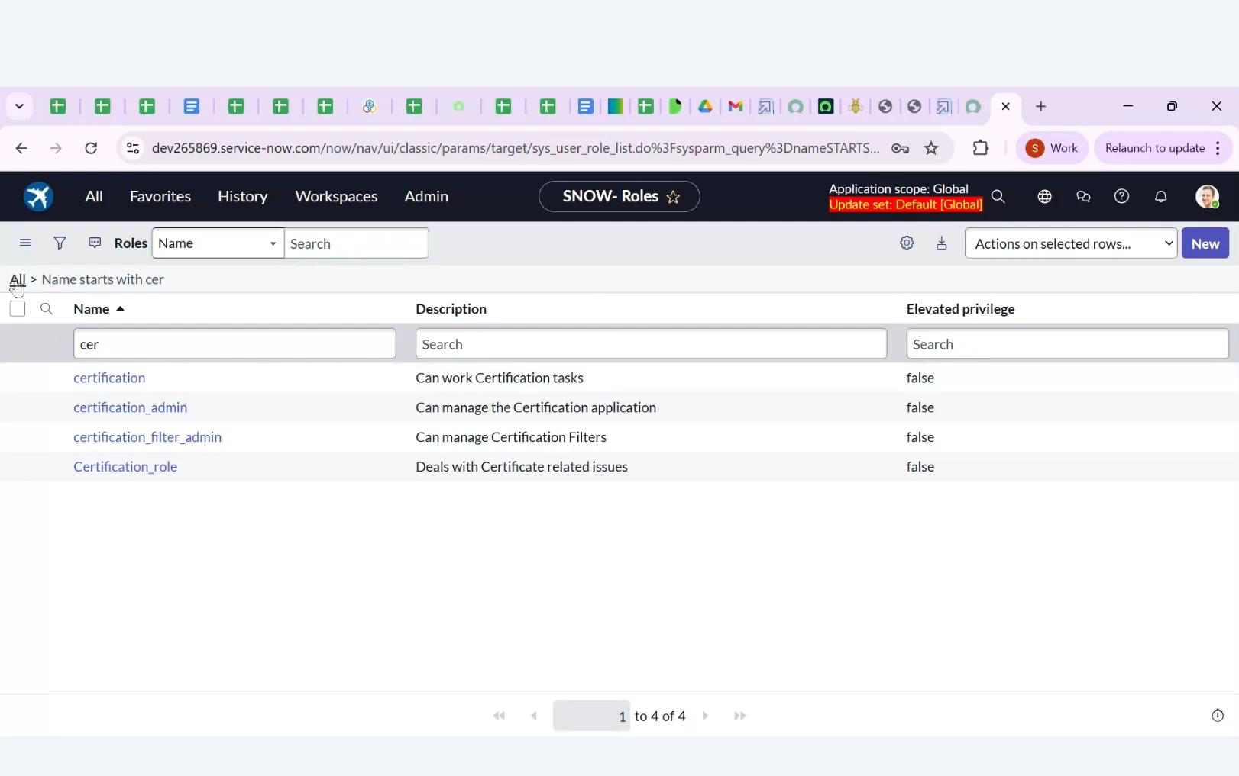

Milestone 4 : Table
Activity 1: Create Table
1. Open service now.
2. Click on All >> search for tables
3. Select tables under system definition
4. Click on new
5. Fill the following details to create a new table
Label : project table
Check the boxes Create module & Create mobile module
6. Under new menu name : project table
7. Under table columns give the column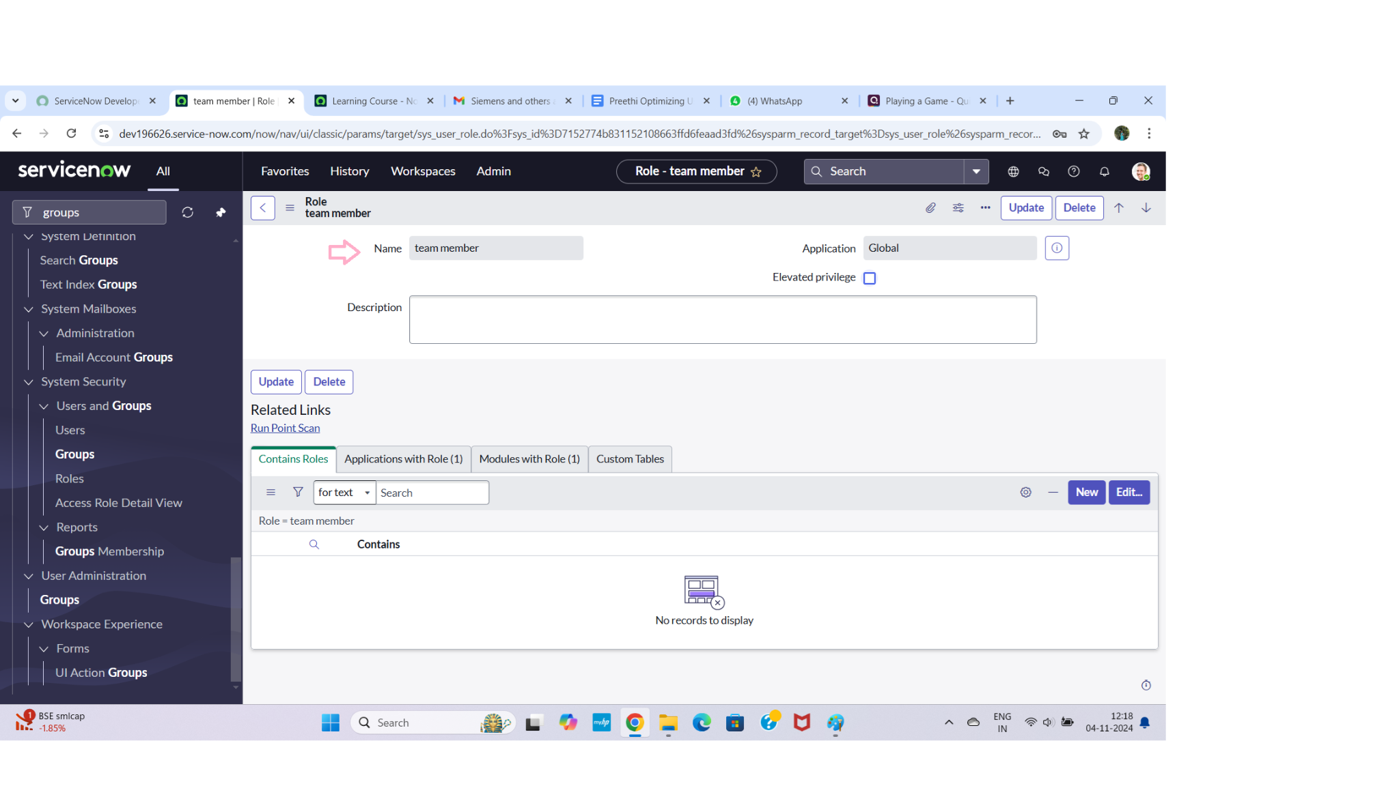
8. Click on submit

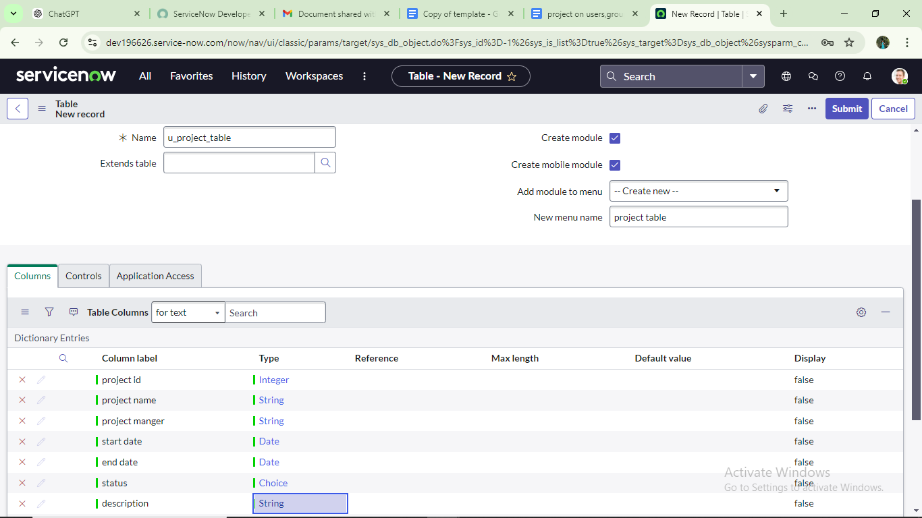

Create one more table:
9.Create another table as:task table 2 and fill with following details.
10. Click on submit.

Milestone 5 : Assign Roles & Usrs to certificate group
Activity 1: Assign users to project team group
1.Open service now.
2.Click on All >> search for groups
3.Select tables under system definition
4.Select the project team group
5.Under group members
6.Click on edit
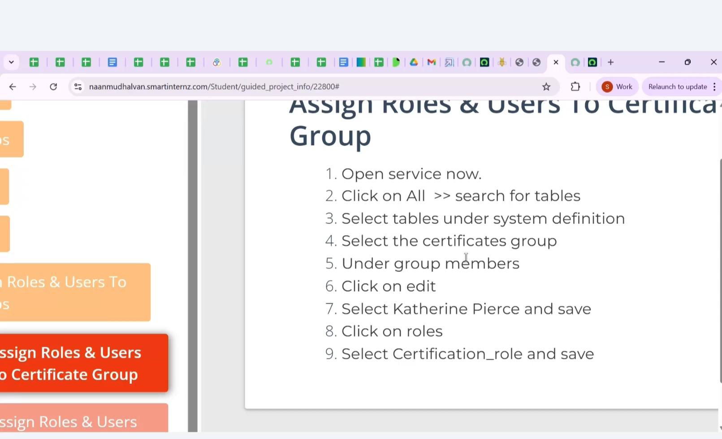

Milestone 6 : Assign roles to table
Activity 1: Assign roles to alice user
1.Open servicenow.Click on All >> search for user
2.Select tables under system definition
3.Select the project manager user
4.Under project manager
5.Click on edit
6.Select project member and save
7.click on edit add u_project_table role and u_task_table role
8.click on save and update the form

Create ACL
1. Open service now.
2. Click on All >> search for ACL
3. Select Access Control(ACL) under system security
4. Click on now
5. Fill the following details to create a now ACL
6. Scroll down under requires role

7. Double click on insert a new row
8. Give admin rale
9. Click on submit
10. Similarly create 4 acl for the following fields

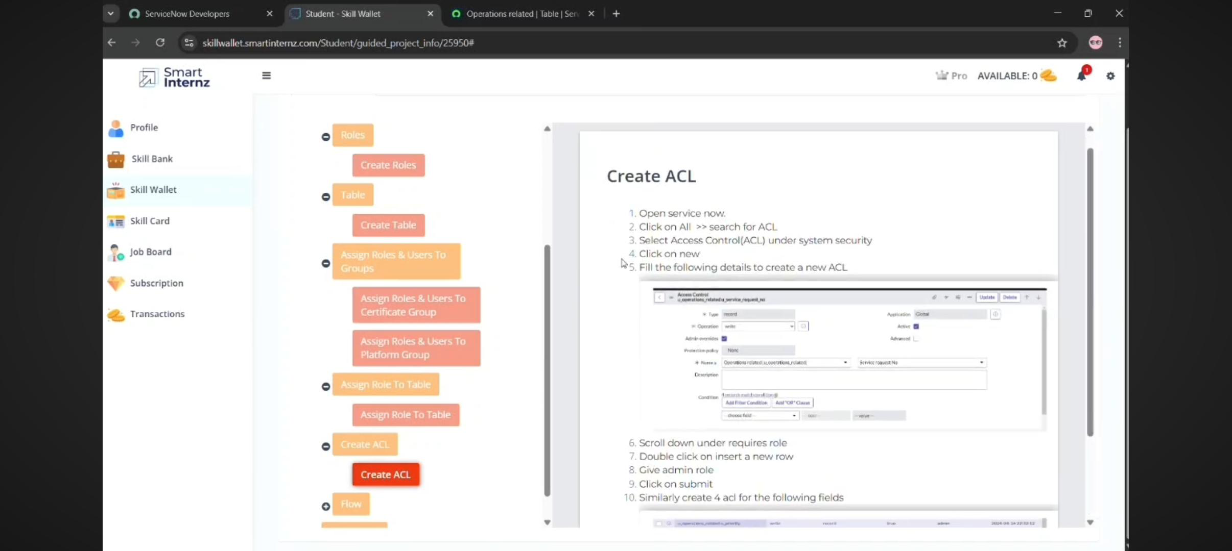

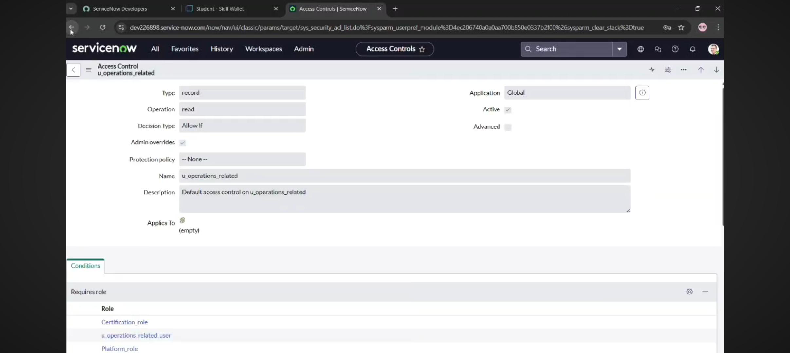

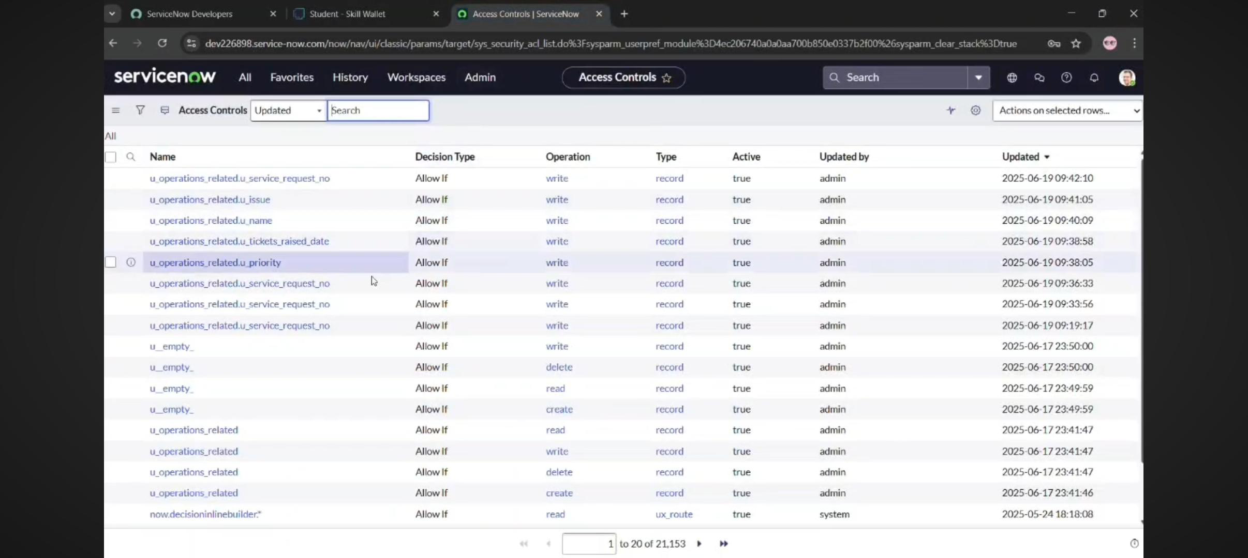
Create A Flow To Assign Operations Ticket To Group
1. Open service now.
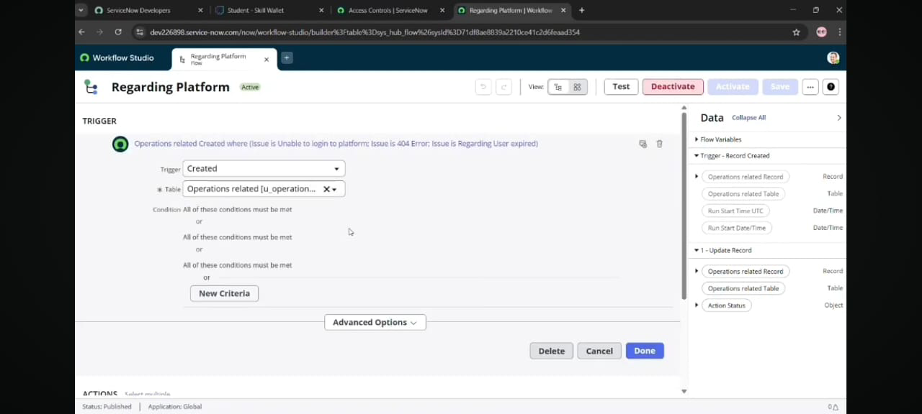
2. Click on All >> search for Flow Designer
3. Click on Flow Designer under Process Automation.
4. After opening Flow Designer Click on new and select Flow.
5. Under Flow properties Give Flow Name as Regarding Certificate".
6. Application should be Global
7. Select Run user as System user from that choice.
8. Click on Submit
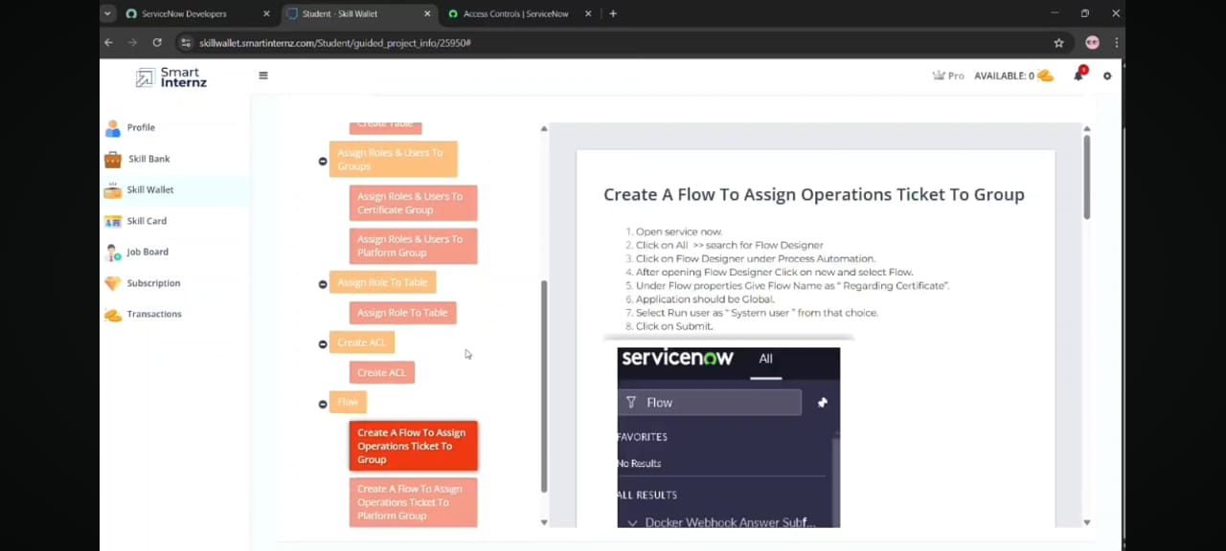

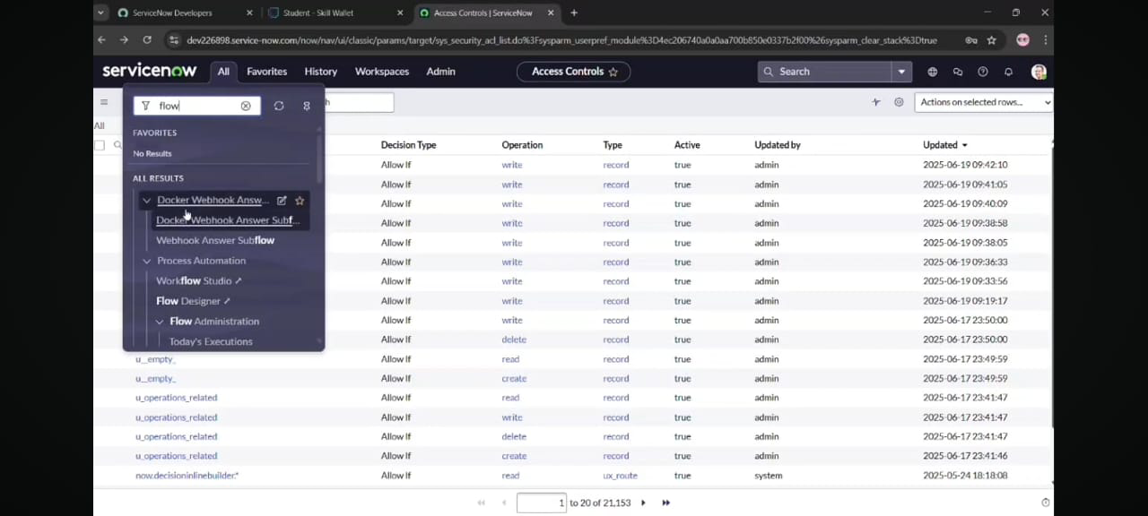

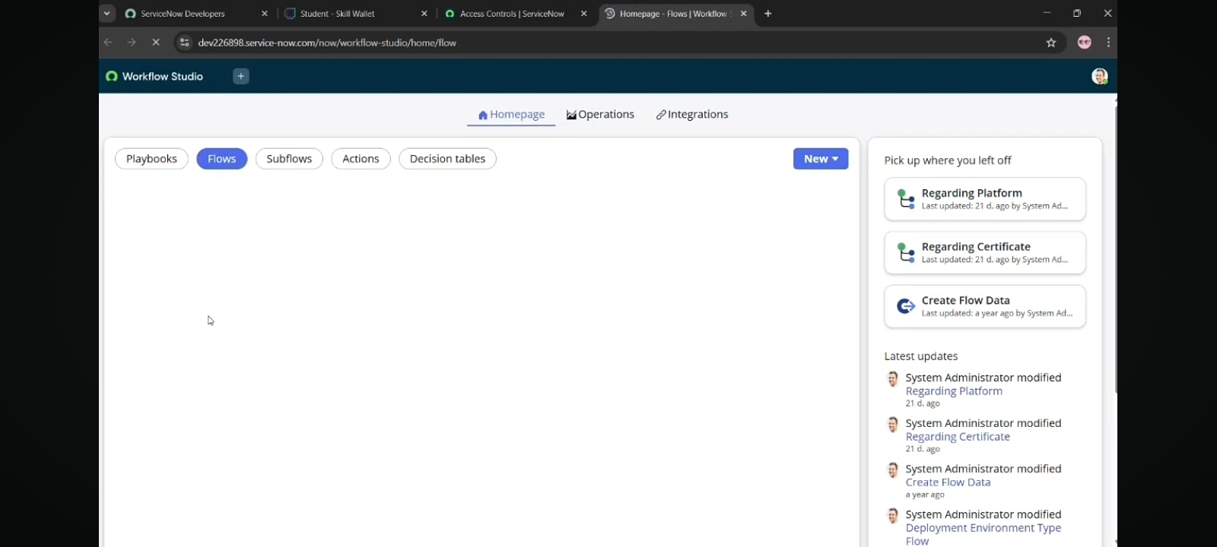

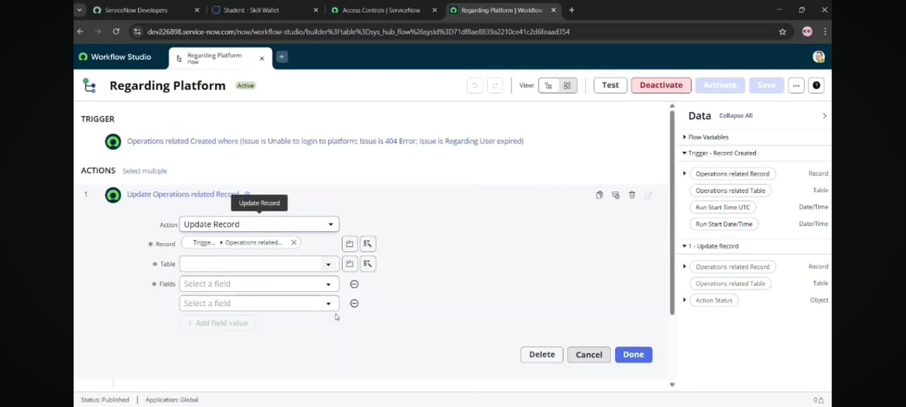
Create A Flow To Assign Operations Ticket To Platform Group
1. Click on Add a trigger
2. Select the trigger in that Search for "create or update a record" and select that.
3. Give the tabile name as Operations related"
4. Give the Condition as
Field: issue
Operator: is
Value: Unable to login to platform
5. Click on New Criteria
Field: issue
Operator: is
Value: 404 Error
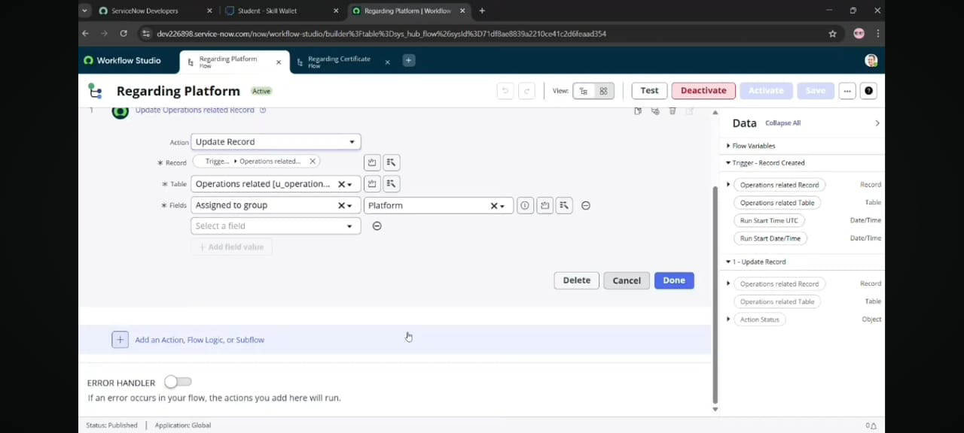6. Click on New Criteria
Field: issue
Operator: is
Value: Regrading User expired
7. After that click on Done.
8. Now under Actions.
9. Click on Add an action
10. Select action in that search for Update Record"
11. In Record field drag the fields from the data navigation from left side
12. Table will be auto assigned after that
13. Give the field as Assigned to group"
14. Give value as" Platform"
15. Click on Done.
16. Click on Save to save the Flow.
17. Click on Activate.
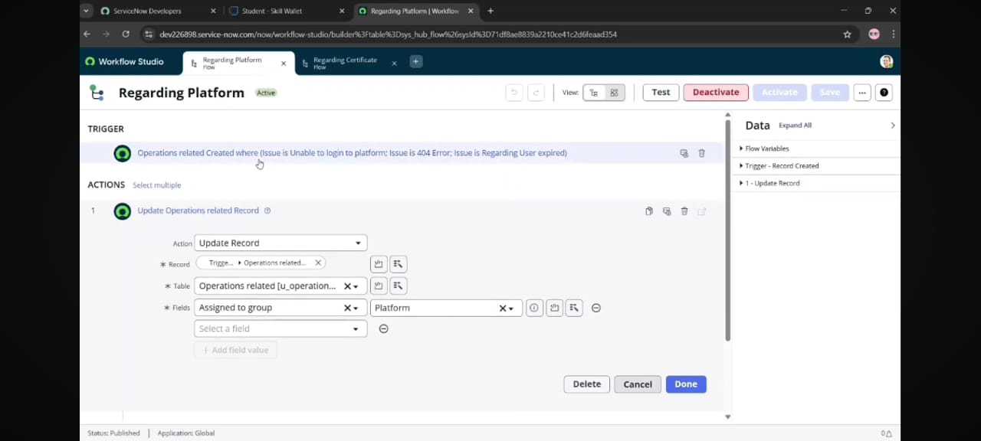

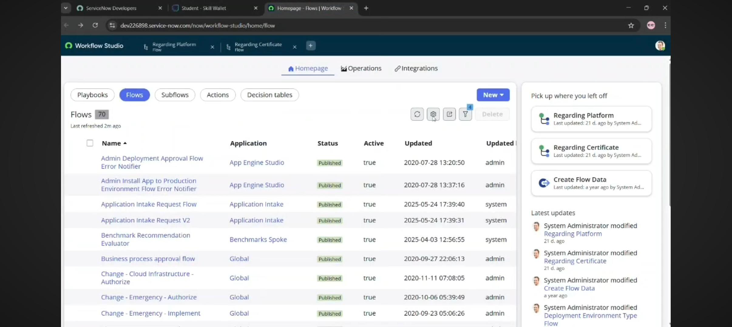
Conclusion
The implementation of the automated ticket routing system at ABC Corporation has been a significant success. By leveraging the capabilities of ServiceNow, we have streamlined the process of assigning support tickets to the appropriate teams, addressing the challenges of manual routing, and ensuring tirnely resolution issues.